TITLE OF THE STUDY

A PROSPECTIVE STUDY TO ASSESS THE QUALITY OF LIFE (QOL) IN BREAST CANCER PA TIENTS AND FACTORS AFFECTING QUALITY OF LIFE

INTRODUCTION
Breast cancer continues to be the most prevalent malignancy among women worldwide, highlighting the need to extend clinical focus beyond survival outcomes to a more comprehensive evaluation of patient well-being through health-related quality of life measures. This multidimensional perspective is essential, as improvements in survival do not always correspond with better overall health status. Many survivors experience a gap between physical recovery and perceived well-being, with only a small proportion reporting high levels of overall health despite successful treatment. In the South Asian context, particularly in countries such as India, Bangladesh, Nepal, and Pakistan, the assessment of quality of life is especially important due to the influence of region-specific challenges. Socioeconomic factors, including illiteracy, unemployment, and limited access to healthcare services, significantly contribute to poorer quality of life outcomes among breast cancer patients. In India, the increasing incidence of breast cancer has placed substantial pressure on healthcare systems, often resulting in insufficient attention to survivorship care following treatment.
This lack of continued care is concerning, as many patients report ongoing issues such as persistent fatigue and financial burden, which adversely affect long-term recovery. Additionally, older patients, particularly those aged 40 years and above, are more likely to experience diminished quality of life across physical, emotional, and functional domains compared to younger individuals. Treatment modalities also play a crucial role, with evidence suggesting that patients undergoing breast-conserving surgery tend to report better psychosocial outcomes, including improved confidence and sexual well-being, compared to those who undergo more extensive surgical procedures.
Furthermore, clinical factors such as ongoing chemotherapy and shorter treatment durations have been associated with poorer symptom management and reduced overall health status. Changing lifestyle patterns, including delayed marriage and late-age pregnancy, have also been identified as contributing factors to the rising incidence of breast cancer in the Indian population. Financial challenges remain a significant concern, with some patients unable to continue treatment due to economic constraints, while others resort to borrowing under high financial pressure to meet medical expenses. Overall, these factors underscore the importance of evaluating health-related quality of life in breast cancer patients, particularly in resource-limited settings, to inform more holistic and patient-centered approaches to care.
TYPES OF BREAST CANCER
Most common type of breast cancer
- Ductal Carcinoma in Situ (DCIS)
- Invasive breast cancer (ILS / IDC)
Less common type of breast cancer
- Triple-negative breast cancer
- Recurrent breast cancer
- Metastatic breast cancer
Rare type of breast cancer
- Lobular Carcinoma in Situ (LCIS)
- Inflammatory breast cancer
- Paget's disease of the nipple
- Phyllodes tumours
- Angiosarcoma of the Breast
- Male breast cancer
Early Stage
- Ductal Carcinoma in Situ (DCIS): Earliest, non-invasive form of breast cancer. Accounts for 20–25% of new cases. Low risk of spreading outside the milk duct.
Invasive Breast Cancer
- Invasive Ductal Carcinoma (IDC): Most common type (70–80%).
- Invasive Lobular Carcinoma (ILC): Second most common.
- Other rare IDC subtypes: medullary, tubular, papillary, mucinous, cribriform.
High-Risk Subtypes
- Triple-Negative Breast Cancer: Lacks hormone receptors & HER2. Difficult to treat.
- HER2-Positive Breast Cancer: About 15% of cases, aggressive but treatable with targeted therapy.
Recurrence & Spread
- Recurrent Breast Cancer: Returns after treatment; 7–11% of early cases recur within 5 years.
- Metastatic Breast Cancer: Spreads to distant organs; ~7% present with metastasis at diagnosis.
Rare Types
- Lobular Carcinoma in Situ (LCIS): Not true cancer but raises risk.
- Inflammatory Breast Cancer: Aggressive, causes breast swelling/redness; 1–5% of cases.
- Paget’s Disease of Nipple: 1–3% of cases, starts in ducts → nipple/areola.
- Phyllodes Tumours: Stromal tissue growth, mostly benign, seen in women ~40s.
- Angiosarcoma: Rare, linked to prior radiation, arises in blood/lymph vessels.
- Male Breast Cancer: Very rare, usually in older men, curable if detected early.

CAUSES
Genetic & Family Factors
- Family history increases risk, especially if close relatives had breast cancer. Inherited mutations like BRCA1/BRCA2 raise chances of breast and ovarian cancers.
Hormonal & Biological Factors
- Risk rises with age (50+), early menstruation, late menopause, or long exposure to oestrogen /progesterone. Dense breast tissue also makes cancer more likely and harder to detect.
Lifestyle & Environmental Factors
- Alcohol, obesity, inactivity, smoking, and poor diet increase risk by altering hormones and causing inflammation. Radiation exposure to the chest at a young age is another contributor.

Other Considerations
- Not all women with risk factors develop breast cancer, and some without them still do. The disease results from a complex interaction of genetics, hormones, lifestyle, and environment, highlighting the importance of prevention, counselling, and regular screening.
STAGES
The Breast Cancer Stages
The degree of disease progression, including tumor size, lymph node involvement, and the existence of distant metastases, is indicated by breast cancer staging, which ranges from Stage 0 to Stage IV. Determining the best course of action, forecasting results, and comprehending the possible influence on a patient's quality of life all depend on this classification.
Because treatment is frequently more effective and less invasive, patients who are diagnosed at earlier stages (Stages 0–II) typically have better results and a higher quality of life. On the other hand, later stages, especially metastatic breast cancer, are linked to a worse prognosis and more difficulties since they frequently call for intense systemic treatments and concentrate more on palliative care and symptom management.
Moreover, molecular categorization into subtypes based on hormone receptor and HER2 expression, such as luminal A, luminal B, HER2-positive, and triple-negative, offers further understanding of disease behavior and therapy planning. Each subtype is associated with unique patterns of treatment response, side effects, and recurrence risk, all of which have a substantial impact on the patient's social functioning, mental well-being, and physical state. The Tumor–Node–Metastasis (TNM) system, which offers a consistent and methodical approach to assessing disease severity, is frequently used to guide the staging process. The main tumor's size and extent are indicated by the "T" component, the degree of regional lymph node involvement is indicated by the "N," and the presence of distant metastatic dissemination is indicated by the "M" component. Clinicians can effectively classify the illness and develop EBT solutions thanks to this all-encompassing approach.

Pathophysiology of Breast Cancer

The development of breast cancer is influenced by a complex interplay of genetic, hormonal, and environmental factors. Understanding its underlying biological mechanisms is important for interpreting disease progression and its effects on patients’ quality of life. Breast cancer typically arises from the abnormal and uncontrolled growth of epithelial cells in the ducts or lobules of the mammary gland. This process is often initiated by mutations in oncogenes or tumor suppressor genes, which interfere with normal cellular regulation, leading to disrupted growth and differentiation.
As these cancerous cells multiply, they can develop into a primary tumor that, if left untreated, might migrate to other areas of the body, affecting the prognosis and general health. The tumor's aggressiveness and response to therapy are further defined by variations in histological type, tumor grade, and receptor status, such as estrogen receptor (ER), progesterone receptor (PR), and HER2. These factors ultimately influence treatment choices and patient outcomes. At the molecular level, deregulation of important signaling pathways, such as PI3K/Akt/mTOR and MAPK, which are crucial for cell survival, growth, and proliferation, is frequently linked to the advancement of breast cancer. Furthermore, hereditary mutations in genes such as BRCA1 and BRCA2 enhance susceptibility by impairing DNA repair pathways, making people more vulnerable to early-onset and more aggressive forms of the illness.

SIGNS AND SYMPTOMS:
DIAGNOSIS:
Breast Exam
First step in diagnosis. A healthcare professional checks for skin/nipple changes and feels for lumps in the breast, collarbone, and armpits.
- Mammogram
X-ray of breast tissue used for screening. A diagnostic mammogram provides a closer look if abnormalities are found.
- Breast Ultrasound
Uses sound waves to show if a lump is solid or fluid-filled, helping guide further tests.
- Breast MRI
Magnetic field and radio waves create detailed images. Contrast dye highlights suspicious areas in one or both breasts.
- Biopsy
A needle removes a tissue sample guided by imaging. This is the definitive test to confirm cancer. A marker may be placed at the site for monitoring.
- Lab Testing
Biopsy samples are analysed to confirm cancer, identify type, growth rate, and check hormone receptors or HER2 status.
- IHC (Immunohistochemistry) Testing
Special lab test on biopsy samples. Detects hormone receptors (ER, PR) and HER2 protein on cancer cells. Results guide targeted therapy and treatment planning.
- Staging Tests
Once cancer is confirmed, staging determines spread. Tests may include blood work, bone scan, CT, MRI, or PET scan. Complete staging may be available only after surgery.

TREATMENT
Here’s a humanised, student-friendly version of breast cancer treatment with clear headings and medium-length explanations for your PPT:
Surgery
Surgery is often the first step in treatment. A lumpectomy removes only the tumour and a small margin of healthy tissue, usually followed by radiation. A mastectomy removes the entire breast and may be chosen for larger or multiple tumour. Lymph node procedures include sentinel node biopsy (removing a few nodes to check spread) and axillary dissection (removing more nodes if cancer is found). Some patients may also opt for contralateral prophylactic mastectomy to reduce risk in the other breast. Reconstruction can restore breast shape after mastectomy.
Radiation Therapy
Radiation uses high-energy beams (like X-rays or protons) to kill leftover cancer cells after surgery. It lowers the chance of recurrence. Most commonly, external beam radiation is used, while brachytherapy places radiation inside the body. Side effects include fatigue, skin irritation, swelling, and rarely damage to nearby organs.
Chemotherapy
Chemotherapy uses strong medicines, often in combinations, to destroy cancer cells. It may be given after surgery to reduce recurrence risk or before surgery to shrink tumour and make them easier to remove. In advanced cases, it helps control spread and relieve symptoms. Side effects include hair loss, nausea, fatigue, infection risk, and rarely nerve damage or early menopause.
Hormone Therapy
This treatment is used for cancers sensitive to oestrogen or progesterone. Medicines block hormones from attaching to cancer cells or stop the body from making oestrogen (e.g., aromatase inhibitors). Sometimes, ovarian function is suppressed with drugs or surgery. Side effects include hot flashes, night sweats, vaginal dryness, and risks like bone thinning or blood clots.

Targeted Therapy
Targeted drugs act on specific proteins in cancer cells. The most common target is HER2, a protein that helps cancer grow. Medicines block HER2 activity, killing cancer cells while sparing healthy ones. Targeted therapy may be used before surgery to shrink tumours, after surgery to prevent recurrence, or in advanced disease.
Immunotherapy
Immunotherapy boosts the body’s immune system to recognize and attack cancer cells. It is especially useful in triple-negative breast cancer, which lacks hormone receptors and HER2.
QUALITY OF LIFE
“Quality of life is an individual's perception of their position in life in the context of the culture and value systems in which they live and in relation to their goals, expectations, standards and concerns.”
QOL in Breast cancer
Quality of Life is a broad concept that reflects how patients feel physically, emotionally, socially, and in their daily activities. For breast cancer patients, treatments often bring physical problems like fatigue, nausea, pain, lymphedema, menopausal symptoms, and sleep disturbances. Beyond the physical side, many women struggle with emotional challenges such as anxiety, depression, fear of recurrence, and changes in body image or self esteem. Socially, the disease can affect family roles, work productivity, sexual health, and finances, all of which can reduce overall well-being.
Different treatments affect QOL in different ways. Surgery may change how women feel about their body and femininity. Chemotherapy often causes hair loss and tiredness, while radiotherapy can lead to skin changes and long-term tissue effects. Hormonal and targeted therapies may trigger menopausal symptoms, joint pain, or even heart problems. On top of treatment effects, factors like age, marital status, education, income, disease stage, and other health conditions also play a role in shaping QOL.
To measure these impacts, researchers and clinicians use standardized tools such as the EORTC QLQ C30 and its breast cancer specific module, QLQ BR23. These questionnaires assess physical, emotional, cognitive, social, and role functioning, giving a clearer picture of how patients are coping beyond medical test results. A prospective observational study design is especially useful because it follows patients over time, showing how QOL changes during treatment and survivorship, and helping identify which factors most strongly influence outcomes.
Understanding these influences is vital for planning supportive care, counselling, rehabilitation, and patient education. By evaluating QOL alongside clinical outcomes, healthcare providers can deliver more holistic, patient centered care. Ultimately, the goal is not only to extend life but to ensure that breast cancer survivors live well, with dignity and improved overall well-being.
NABH provide a framework for quality and patient safety in Indian healthcare, covering clinical care, patient rights, medication, infection control, infrastructure, HR, and continuous improvement, focusing on patient-centricity, effectiveness, timeliness, equity, and efficiency to build a culture of quality and accountability.
Patient Reported Outcome Measures (PROMs) are a valuable tool for measuring the effectiveness of health care interventions from the patient's perspective. PROMs are defined as any report of
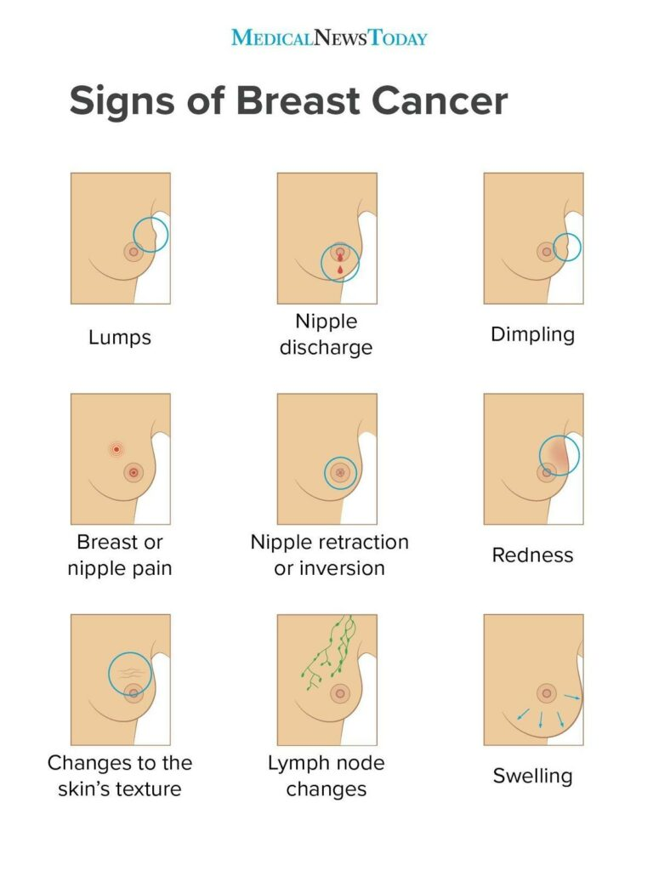
the status of a patient’s health condition that comes directly from the patient, without interpretation by a clinician or anyone else. PROMs can be used to assess a wide range of health
outcomes, including symptoms, functional status, quality of life and satisfaction with care.

AIM OF THE STUDY:
The aim of this study is to longitudinally evaluate the quality of life in breast cancer patients and to investigate the key medical, psychological, and social determinants that influence their well-being during and after treatment."

STUDY OBJECTIVES
Primary objective to assess breast cancer patients’ quality of life using the EORTC QLQ-C30 and EORTC QLQ-BR23 questionnaires.
Secondary objective
To evaluate the various aspects of breast cancer patients’ quality of life, such as their functional, emotional, social and physical well-being.
To assess effects on quality of life of various treatment modalities, including chemotherapy, radiation, hormonal, target therapy and surgery.
To determine a demographic element that influence quality of life, such as age, education and socio-economic status.
To evaluate how treatment related adverse drug reactions affect breast cancer patients quality of life.
To compare the quality of life scores of various breast cancer patient groups.

NEED FOR THE STUDY
- Breast cancer survival is increasing, making quality of life an essential treatment outcome.
- Patients experience significant physical, psychological, and social challenges during and after treatment
- Treatment-related adverse effects can negatively impact daily functioning and wellbeing.
- QOL is often under-assessed in routine clinical practice.
- Early identification of factors affecting QOL can guide timely supportive care.
- Prospective data helps in understanding changes in QOL over the treatment course.
- Findings can support patient-cantered care and improve overall clinical outcomes.
- Modern oncology emphasizes not only survival but also the quality of survivorship. Despite improved life expectancy, breast cancer patients often experience long-term physical, psychological, and social challenges.
- Routine clinical evaluations frequently overlook patient-reported outcomes, leading to under-recognition of symptoms such as fatigue, pain, and emotional distress.
- Interventions like chemotherapy and surgery can result in adverse effects, including lymphedema and altered body image, which significantly impact patients’ overall well-being.
- Financial burden and limited resources, especially in low- and middle-income settings, can affect treatment adherence, coping ability, and emotional health.
- A longitudinal approach helps in understanding changes in QoL over time and identifying critical phases where patients require enhanced support.
- Identifying key demographic and clinical determinants of QoL enables the development of personalized interventions and integration of supportive care into routine oncology practice.
- This study is essential to ensure that breast cancer patients achieve not only prolonged survival but also a meaningful and improved quality of life.

METHODOLOGY
This study utilizes an observational prospective study in Omega hospital, Gachibowli which is a 200 bedded tertiary care hospital with various departments.
STUDY SITE: Omega hospital, Gachibowli, Hyderabad, Telangana.
STUDY DESIGN:
It is a hospital based study to assess the health related quality of life and associated factors among breast cancer patients undergoing treatment at Omega hospital, Gachibowli.
SAMPLE SIZE:
Total of 150 breast cancer patients undergoing various types of breast cancer treatments are included in the study.
INCLUSION CRITERIA:
- Adult female patients>18 years with histologically confirmed breast cancer
- Any stage(I-IV) receiving or planned to receive systemic therapy, radiation therapy or Surgery.
- Able to understand the questionnaire language and give written informed consent
EXCLUSION CRITERIA:
- Patients with severe psychiatric illness or cognitive impairment
- Critically ill patients unable to respond to questionnaires
- Patients unwilling to participate
- Children (<18years)
- Pregnant women
ASSESSMENT TOOL:
Quality of life will be assessed using validated questions such as European Organisation for Research and Treatment of Cancer Quality of Life Questionnaire (EORTC QLQ-C30 ) with breast cancer specified module (QLQ-BR23) / FACT- G. These tools assess physical, role, emotional cognitive and social functioning, alongside symptom scales for pain, fatigue and treatment side effects.
DATA COLLECTION:
Data are collected through face-to-face interviews and clinical record reviews. The questionnaire will be administered to patients during routine hospital visits. Assistance will be provided if required to ensure accurate completion. Information regarding socioeconomic status (education, marital status, income, age) and clinical characteristics (tumour stage, type of surgery, chemotherapy regimen) is recorded to identify correlation with QOL questionnaire scores.
MONITORING AND FOLLOW UP:
Patients will be assessed at baseline and during follow up visits to monitor changes in quality of life across physical, emotional, social and functional domains during treatment.
DATA COLLECTION PROCEDURE:
Data will be collected from medical records and patient-reported questionnaires. Collected data will include:
Demographic details (age, marital status, education level)
Clinical details (type of breast cancer, stage of disease)
Treatment details (chemotherapy, radiotherapy, surgery, hormonal therapy)
Quality of Life scores from questionnaire domains
Factors affecting QoL (treatment side effects, emotional distress, social support).

STATISTICAL METHOD:
- As the study focuses on assessing quality of life and identifying associated factors, descriptive and inferential statistical analysis will be used.
- Measuring the mean and standard deviation of Quality of Life scores across different domains.
- Evaluating the frequency and percentage distribution of patients based on QoL categories.
- Comparing Quality of Life scores based on treatment modality, disease stage, and demographic factors.
- Assessing the association between clinical variables and QoL using appropriate statistical tests. A p-value < 0.05 will be considered statistically significant.

- The analysis includes demographic characteristics, tumour receptor status, surgical management, and treatment outcomes.

- Chi-square tests were used to assess associations between categorical variables and outcomes (lymphedema, radiation therapy).

- An independent samples t-test was used for continuous age comparison.

RESULTS :

1.1 Age Distribution (t-test)
Overall: Mean age = 54.4 years (SD = 10.1), Median = 54 years, Range = 23–80 years.

Statistic | No Lymphedema | Lymphedema | t-statistic | p-value
n | 103 | 47
Mean ± SD (years) | 53.4 ± 10.2 | 56.4 ± 9.8 | -1.684 | 0.094

Table 1. Independent t-test comparing age between lymphedema groups. Significance: ns (p>=0.05)

The average age of the study participants was in the mid-fifties, with values ranging from young adulthood to elderly individuals. When comparing groups, patients who developed lymphedema were slightly older on average than those who did not. However, statistical testing showed that this difference was not significant, suggesting that age did not play a major role in the development of lymphedema within this sample.

1.2 Treatment Outcomes Summary

Treatment/Outcome | Yes (n) | Yes (%) | No (n) | No (%)
Chemotherapy | 144 | 96.0% | 6 | 4.0%
Radiation Therapy | 39 | 26.0% | 111 | 74.0%
Lymphedema | 47 | 31.3% | 103 | 68.7%

Table 2. Distribution of treatment outcomes across the study population.

Outcomes
Most patients in the study underwent chemotherapy, indicating it as the predominant treatment approach. In contrast, only about one-quarter of the participants received radiation therapy. Regarding complications, nearly one-third of the patients experienced lymphedema, while the majority did not develop this condition.

2. Graphical Analysis
The following graphs illustrate the distribution of patient demographics, receptor status, surgical management, and treatment outcomes.

Figure 1: Age Group Distribution
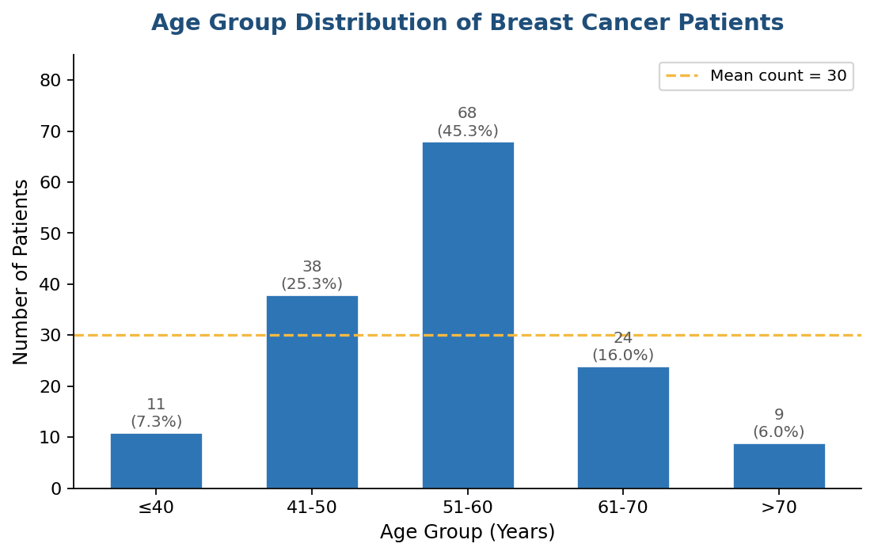
Figure 1. Bar chart showing distribution of breast cancer patients by age group. Numbers above bars indicate count and percentage.
Interpretation: The age distribution demonstrates that the majority of patients are concentrated in middle to older age groups, consistent with established epidemiological trends indicating increased breast cancer incidence with advancing age.

Figure 2: Urban vs Rural Residence
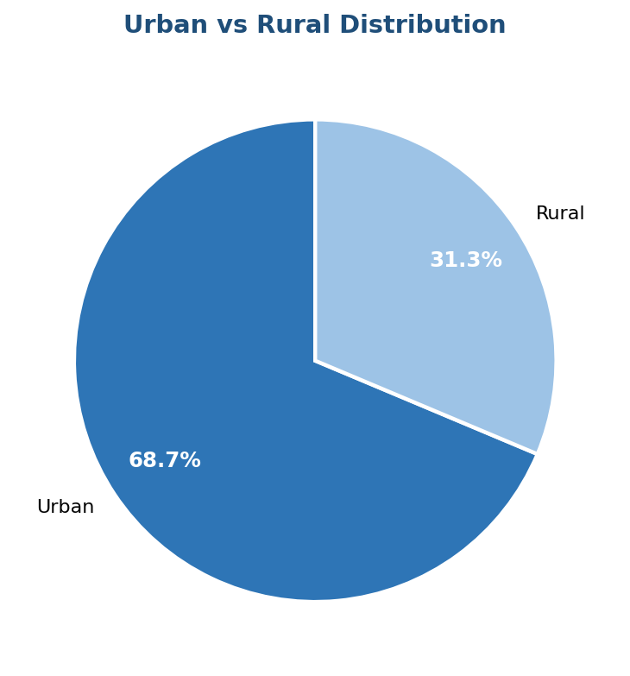
Figure 2. Pie chart showing the proportion of urban vs rural patients.
Interpretation: The urban–rural distribution reflects the healthcare catchment population and may indicate disparities in access to care, awareness, and early detection between these groups.

Figure 3: Education Level
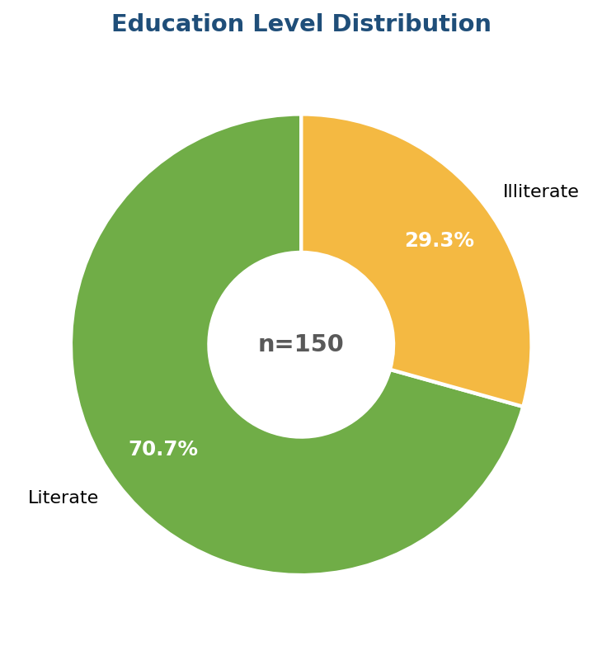
Figure 3. Donut chart showing literate vs illiterate distribution.
Interpretation: The predominance of literate individuals suggests relatively higher educational status; however, literacy alone may not ensure adequate awareness or timely healthcare utilization.

Figure 4: Occupation Distribution
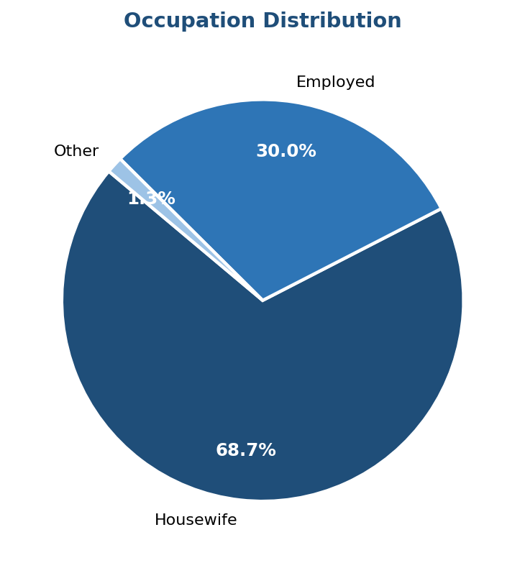
Figure 4. Pie chart showing occupation breakdown (Housewife, Employed, Other).
Interpretation: The higher proportion of housewives reflects socio-cultural patterns that may influence healthcare access, health-seeking behaviour, and decision-making autonomy.

Figure 5: Socioeconomic Status
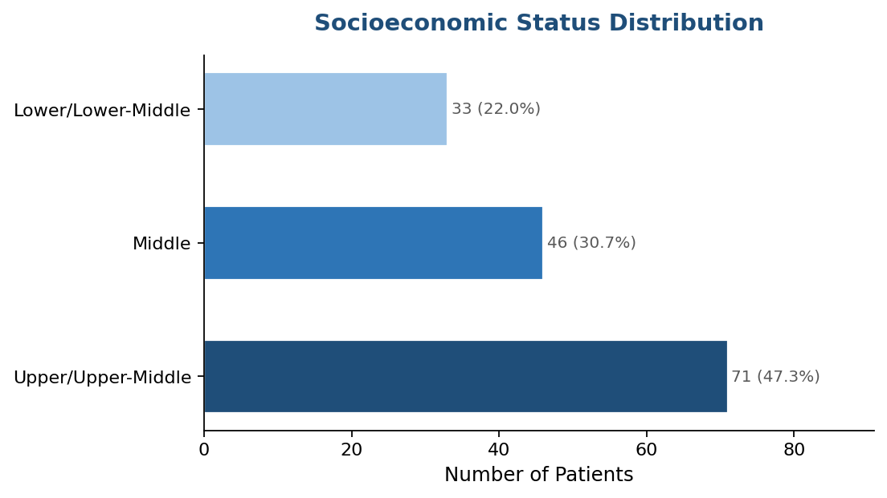
Figure 5. Horizontal bar chart showing distribution across socioeconomic strata.
Interpretation: The presence of patients across all socioeconomic strata indicates widespread disease occurrence, although socioeconomic differences may affect access to diagnosis and treatment.

Figure 6: Receptor Status (HER2 & ER/PR)
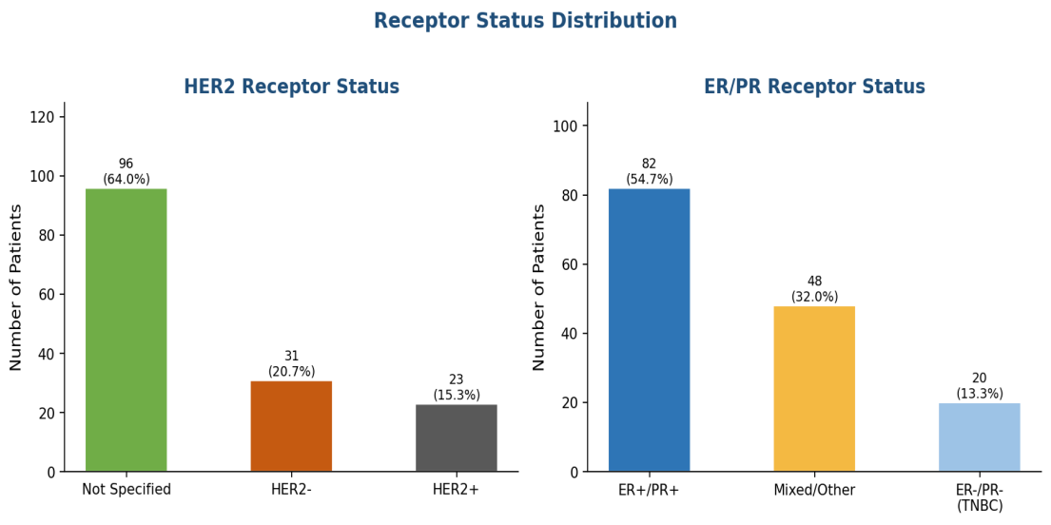
Figure 6. Bar charts showing HER2 (left) and ER/PR (right) receptor status distribution.
Interpretation: The variability in HER2 and ER/PR receptor status highlights tumor heterogeneity, which is critical for determining prognosis and guiding targeted therapeutic strategies.

Figure 7: Surgery Type
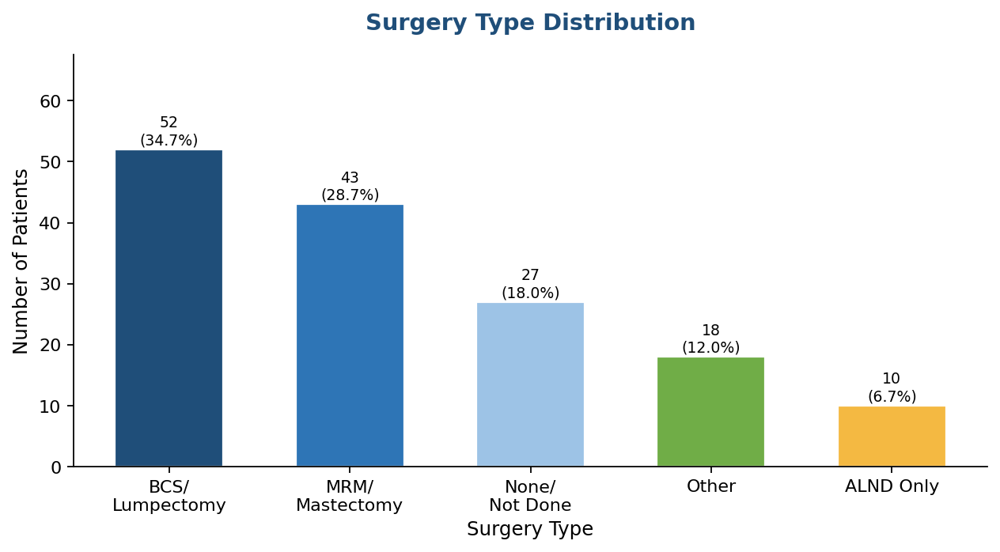
Figure 7. Bar chart showing surgical procedure distribution across the cohort.
Interpretation: The distribution of surgical procedures suggests individualized treatment planning based on tumour characteristics, disease stage, and patient-specific factors.

Figure 8: Treatment & Outcome Distribution
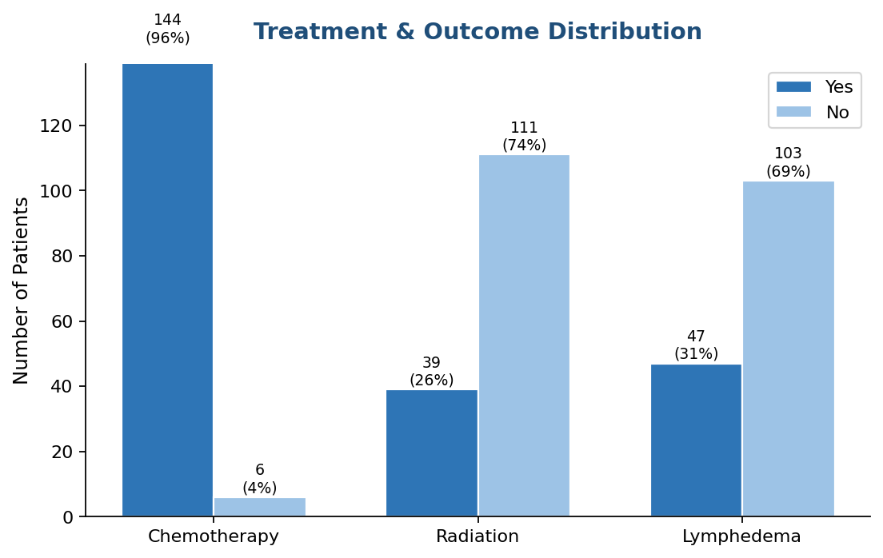
Figure 8. Grouped bar chart showing Yes/No proportions for Chemotherapy, Radiation, and Lymphedema.
Interpretation: The high utilization of chemotherapy underscores its central role in management, while the considerable incidence of lymphedema reflects significant treatment-related morbidity.

Figure 9: Lymphedema by Age Group
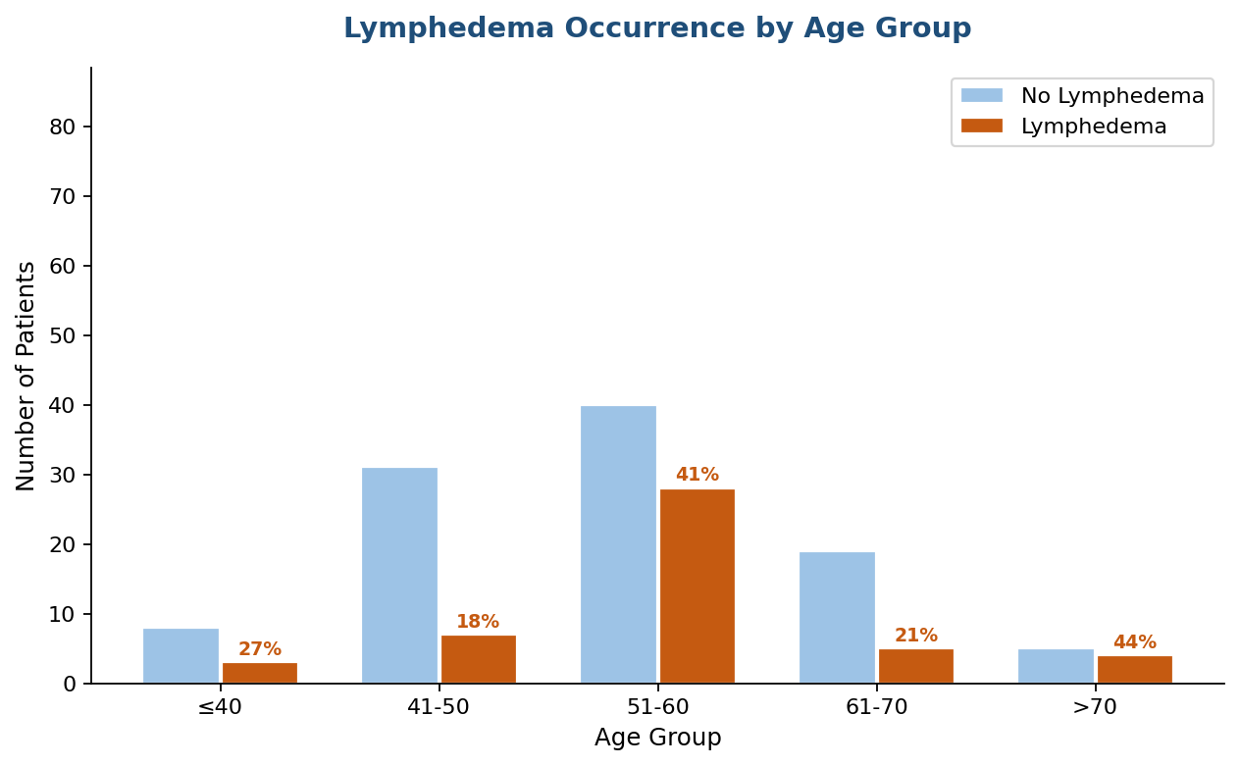
Figure 9. Grouped bar chart comparing lymphedema occurrence (%) across age groups. Red percentages indicate lymphedema rate per group.
Interpretation: A trend toward increased lymphedema incidence with advancing age is suggested, although variability indicates the involvement of multiple contributing factors.

Figure 10: P-Value Heatmap (Chi-Square Tests)
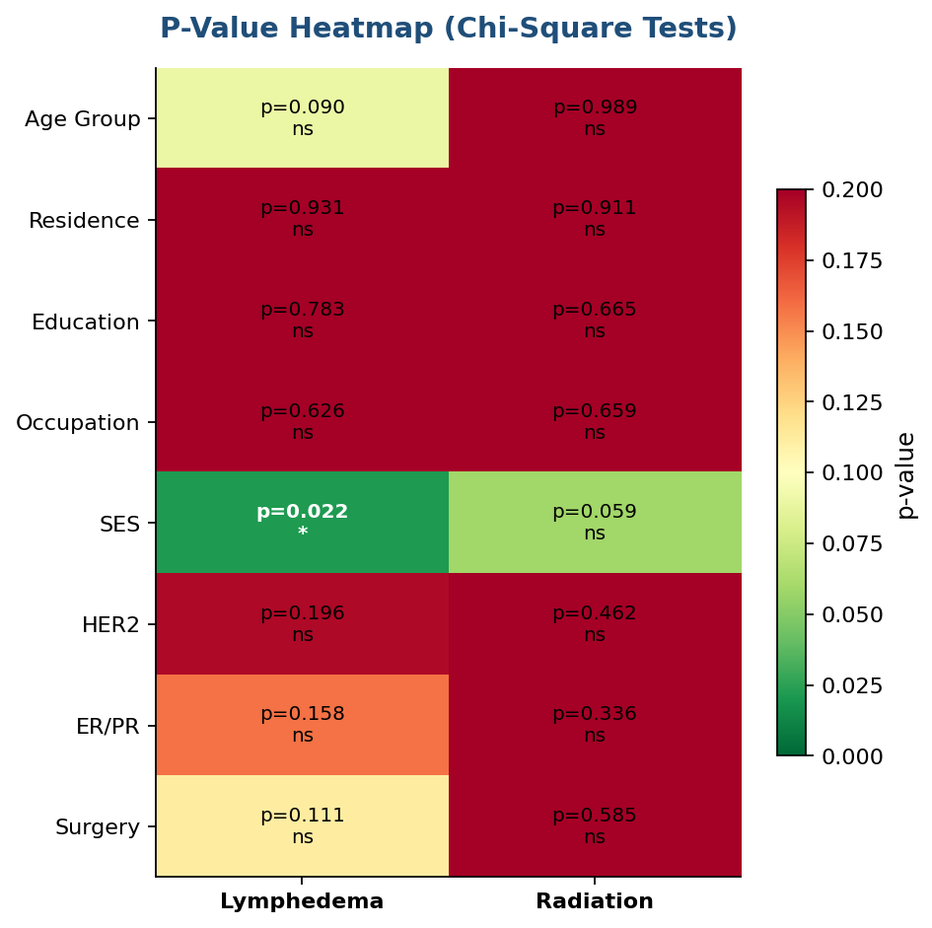
Figure 10. Heatmap of chi-square p-values for all variables vs lymphedema and radiation outcomes. Green = significant (p<0.05).
Interpretation: Statistically significant associations (p < 0.05) identified in the heatmap may represent key predictors of outcomes, whereas non-significant variables show no independent association.

DISCUSSION
Demographic Trends and Socioeconomic Profile
The demographic characteristics of the study population (n=150) provide essential context for interpreting clinical outcomes. The average age of patients was 54.4 years (SD = 10.1), with a median of 54 years. A substantial proportion of patients (45.3%) fell within the 51–60-year age group, indicating that breast cancer was most prevalent in this middle-aged category. The age distribution ranged widely from 23 to 80 years, reflecting that the disease affects individuals across various life stages.
Most participants were from urban areas (68.7%), while a smaller proportion resided in rural regions (31.3%). Educational status showed that 70.7% of patients were literate, whereas 29.3% lacked formal education. In terms of occupation, a large majority were homemakers (68.7%), with 30.0% being employed.
Socioeconomic distribution revealed that nearly half of the patients (47.3%) belonged to the upper or upper-middle class, followed by 30.7% in the middle class and 22.0% in the lower or lower-middle class. This indicates that a considerable portion of the study group had relatively better socioeconomic standing, which may influence healthcare accessibility and treatment decisions.
Clinical Characteristics and Receptor Status
Tumour receptor profiling plays a vital role in guiding breast cancer management. In this cohort, 64.0% of patients were HER2-negative, while 20.7% were HER2-positive; 15.3% had unknown HER2 status.
Hormone receptor analysis showed that ER+/PR+ tumours were most common, observed in 54.7% of patients. Triple-negative breast cancer, typically associated with poorer prognosis, accounted for 13.3% of cases. The remaining patients had mixed or unreported receptor profiles. This predominance of hormone receptor-positive cancers aligns with typical breast cancer patterns and supports the use of hormone-based therapies.
Treatment Outcomes and Surgical Management
Management strategies in this cohort largely followed a multimodal approach. Chemotherapy was administered to the vast majority of patients (96.0%), making it the most commonly used treatment. Radiation therapy was utilized in 26.0% of cases.
Regarding surgical interventions, breast-conserving surgery (lumpectomy/BCS) was the most frequently performed procedure (34.7%), followed by modified radical mastectomy (28.7%). Notably, 18.0% of patients did not undergo any surgical procedure. These findings suggest a preference for breast conservation in a significant proportion of patients, although mastectomy remains an important option.
A key complication identified was lymphedema, affecting 31.3% of patients. This highlights the importance of monitoring and managing long-term treatment-related complications.

Statistical Analysis of Lymphedema and Socioeconomic Status
The statistical evaluation identified a meaningful relationship between socioeconomic status and the occurrence of lymphedema. The chi-square test demonstrated a significant association (p=0.022), indicating that socioeconomic factors play a role in the development of this complication. Although the exact direction of this relationship was not specified, the finding emphasizes the influence of socioeconomic conditions on patient outcomes.
In contrast, age did not show a statistically significant association with lymphedema (p=0.094), suggesting that age alone may not be a determining factor in its development.
Additionally, no significant associations were observed between radiation therapy outcomes and variables such as age, residence, education, occupation, socioeconomic status, or receptor status (p > 0.05). This implies that radiation therapy outcomes were consistent across different subgroups within the study population.
Limitations of the Analysis
Certain limitations should be considered when interpreting these findings. Although the sample size of 150 patients is adequate for preliminary analysis, it may not fully represent the broader population. Missing data, such as unspecified HER2 status (15.3%) and absence of surgical intervention in some patients (18.0%), may influence the overall conclusions.
Furthermore, the study lacks detailed insights into the underlying reasons for socioeconomic disparities and does not explore specific barriers to care. These factors limit the ability to draw causal inferences regarding the association between socioeconomic status and lymphedema.

CONCLUSION
This study provides a comprehensive evaluation of demographic, clinical, and treatment-related factors among 150 breast cancer patients. The population was predominantly middle-aged, urban-based, and largely from middle-to-upper socioeconomic backgrounds. Chemotherapy was the most commonly administered treatment, and breast-conserving surgery was the preferred surgical approach in a considerable number of cases.
The most significant finding of this analysis is the statistically significant association between socioeconomic status and the occurrence of lymphedema (p=0.022). This highlights the potential impact of socioeconomic determinants on post-treatment complications and overall patient outcomes. In contrast, factors such as age did not demonstrate a significant relationship with lymphedema, and radiation therapy outcomes appeared unaffected by the studied variables.
These findings underscore the importance of addressing socioeconomic disparities in breast cancer care, particularly in the prevention and management of complications like lymphedema. Future studies involving larger and more diverse populations, along with detailed clinical and social data, are necessary to better understand these relationships and improve patient quality of life.
Furthermore, patient counselling plays a vital role in improving quality of life by providing emotional support, enhancing adherence to treatment, and guiding patients in managing therapy-related side effects. It also helps in increasing awareness, encouraging healthy lifestyle practices, and strengthening support systems, thereby contributing to better overall patient outcomes.

